10.1.8 Editors - Geometry Nodes Editor - Header - Add Menu - Geometry
Detailed table of content 1
Add menu - Geometry 1
Join Geometry 1
Transform 2

Detailed table of content
Detailed table of content
Detailed table of content 1
Add menu - Geometry 1
Join Geometry 1
Inputs 2
Geometry 2
Output 2
Geometry 2
Transform 2
Inputs 2
Geometry 2
Translation 2
Rotation 2
Scale 2
Output 2
Geometry 2

Add menu - Geometry
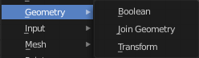
Here you find nodes to modify the geometry.

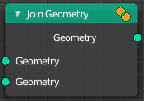
Join Geometry
The Join Geometry enables you to merge separately generated pieces of geometry into a single one. In case that the inputted pieces contain different types of geometry, the output will contain multiple types of geometry.

Inputs

Geometry
Standard geometry input.

Output

Geometry
Standard geometry output.

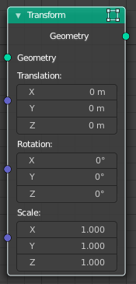
Transform
Move, rotate or scale the geometry. The transformation is applied to the entire geometry, and not per element. For example, you can not rotate individual point cloud points with this node.

Inputs

Geometry
Standard geometry input.

Translation
Translates the geometry in local space of the modified object.

Rotation
Euler rotation in local space.

Scale
Scale to transform the geometries in local space.

Output

Geometry
Standard geometry output.

